Average and Total Numbers of Land Animals*
Who Died to Feed Americans in 2012
*Figures for sea animals not yet available

Chickens
- Total number died for food: 7.6 billion
(7.1 billion for meat, 439 million for eggs)
- Average number killed per American meat-eater: 24.9
(23.4 for meat, 1.4 for eggs)
- Average per American lifetime: 1,951
(1,840 for meat, 111 for eggs)

Turkeys
- Total number died for food: 255 million
- Average per American meat-eater: 0.84
- Average per American lifetime: 66

Pigs
- Total number died for food: 111 million
- Average per American meat-eater: 0.37
- Average per American lifetime: 29
.
Steers and Calves
- Total number died for food: 37 million
- Average per American meat-eater: 0.12
- Average per American lifetime: 9.7

Ducks
- Total number died for food: 23.0 million
- Average per American meat-eater: 0.076
- Average per American lifetime: 6.0

Rabbits
- Total number died for food: 2.4 million
- Average per American meat-eater: 0.009
- Average per American lifetime: 0.67

Totals ALL LAND ANIMALS
- Total number died for food: 7.99 billion
- Average per American meat-eater: 26
- Average per American lifetime: 2,062

* Note: Totals may not add up because of independent rounding.

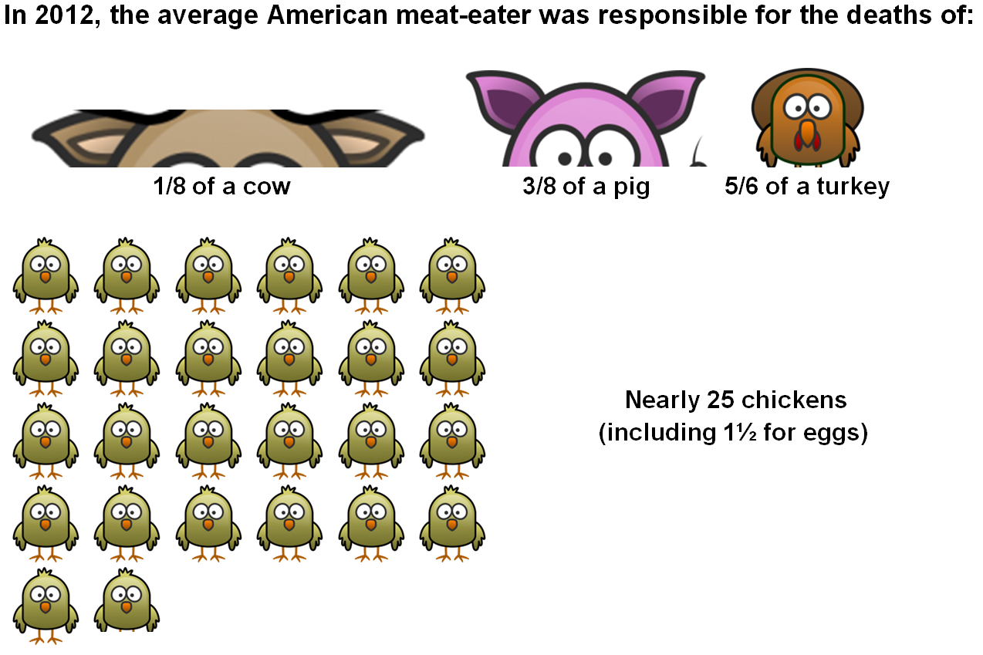
Comparison over time
In 2012, compared to 2011:
- The average meat-eater ate almost 1 fewer land animal — a 3% drop from 27.1 to 26.3 animals.
- This drop was mainly in chickens, both for meat and for eggs. (Cattle also saw a small drop, while pigs and turkeys saw a small increase.)
- Overall, the number of land animals that died for Americans fell from 8.2 to 8.0 billion, or 195 million fewer animals – including 600,000 fewer cows and 200 million fewer chickens, but an additional 2 million pigs and 4 million turkeys.
- This decrease was not accompanied by an increase in animals who died for export. The U.S. slaughtered 103 million fewer land animals.

Long-term trend:
- In 2012, the average meat-eater caused the deaths of fewer animals than any other year going back to at least 2000.
  - That’s fewer cows and fewer chickens than any year since at least 2000, while deaths for pigs, turkeys, and ducks remain at near lows.
- In 2012, the number of animals killed for American meat-eaters dropped below 8 billion for the first time since at least 2000.
  - The number of animals slaughtered fell below 9 billion for the first time since 2002.
- Since peaking in 2004, the average meat-eater eats 5 fewer land animals — a 16% drop from 31.2 to 26.3 animals.
- Overall, that’s a nationwide drop from 8.9 billion in 2005 to 8.0 billion in 2012, or 923 million fewer.

Total Died for American Consumption (millions of animals)
 | Cattle | Pigs | Chickens for Eggs | Chickens for Meat | Turkeys | Ducks |  | All Land Animals
2012 | 37.4 | 111.1 | 439.4 | 7,123 | 254.7 | 23.1 |  | 7,991
2011 | 38.1 | 108.9 | 454.5 | 7,309 | 250.4 | 23.1 |  | 8,189
2010 | 39.1 | 113.9 | 465.4 | 7,535 | 252.8 | 22.3 |  | 8,431
2009 | 39.5 | 118.6 | 446.8 | 7,327 | 255.7 | 21.9 |  | 8,212
2008 | 40.8 | 117.6 | 447.7 | 7,639 | 272.5 | 23.5 |  | 8,544
2007 | 41.6 | 118.4 | 432.5 | 7,989 | 284.0 | 26.9 |  | 8,894
2006 | 41.9 | 114.9 | 409.1 | 8,004 | 272.1 | 27.3 |  | 8,872
2005 | 41.9 | 115.2 | 414.3 | 8,058 | 255.5 | 27.4 |  | 8,914
2004 | 42.9 | 117.6 | 416.2 | 7,995 | 256.4 | 25.8 |  | 8,856
2003 | 41.7 | 117.8 | 410.2 | 7,677 | 264.8 | 24.3 |  | 8,538
2002 | 42.3 | 117.2 | 405.9 | 7,680 | 276.0 | 24.0 |  | 8,547
2001 | 42.2 | 114.5 | 440.1 | 7,371 | 278.8 | 26.3 |  | 8,276
2000 | 42.1 | 116.1 | 406.6 | 7,380 | 271.7 |  |  | 8,246
Average Died Per Meat Eater
 | Cattle | Pigs | Chickens for Eggs | Chickens for Meat | Turkeys | Ducks |  | All Land Animals
2012 | 0.12 | 0.37 | 1.42 | 23.44 | 0.84 | 0.076 |  | 26.27
2011 | 0.13 | 0.36 | 1.48 | 24.23 | 0.83 | 0.077 |  | 27.11
2010 | 0.13 | 0.38 | 1.52 | 25.16 | 0.84 | 0.075 |  | 28.13
2009 | 0.13 | 0.40 | 1.48 | 24.67 | 0.86 | 0.074 |  | 27.63
2008 | 0.14 | 0.40 | 1.49 | 25.93 | 0.92 | 0.080 |  | 28.97
2007 | 0.14 | 0.41 | 1.45 | 27.40 | 0.97 | 0.092 |  | 30.47
2006 | 0.15 | 0.40 | 1.39 | 27.71 | 0.94 | 0.095 |  | 30.69
2005 | 0.15 | 0.40 | 1.42 | 28.17 | 0.89 | 0.096 |  | 31.13
2004 | 0.15 | 0.41 | 1.44 | 28.21 | 0.90 | 0.091 |  | 31.22
2003 | 0.15 | 0.42 | 1.43 | 27.34 | 0.94 | 0.087 |  | 30.37
2002 | 0.15 | 0.42 | 1.43 | 27.58 | 0.99 | 0.086 |  | 30.67
2001 | 0.15 | 0.42 | 1.55 | 26.72 | 1.01 | 0.095 |  | 29.95
2000 | 0.15 | 0.43 | 1.46 | 27.02 | 0.99 |  |  | 30.16
Trend in the number of animals who died for a US meat eater (2000=100%)

All land animals and chickens for meat Egg-laying chickens
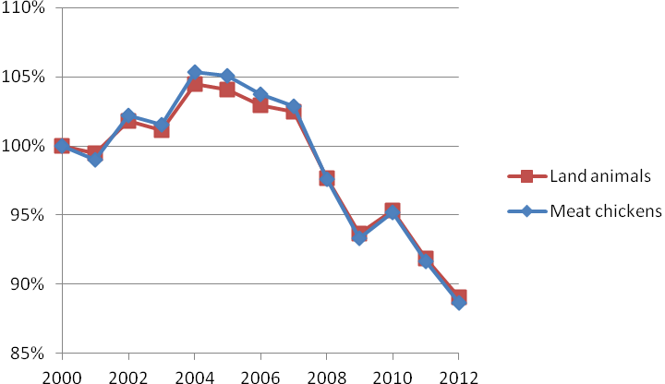 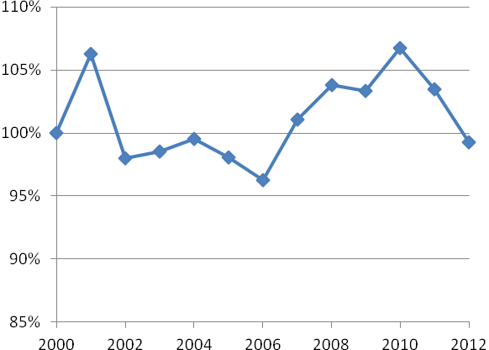
Cattle and Pigs Turkeys and Ducks (2001=100%)
